## Reports/ US Paper Bill Reports:

Request:

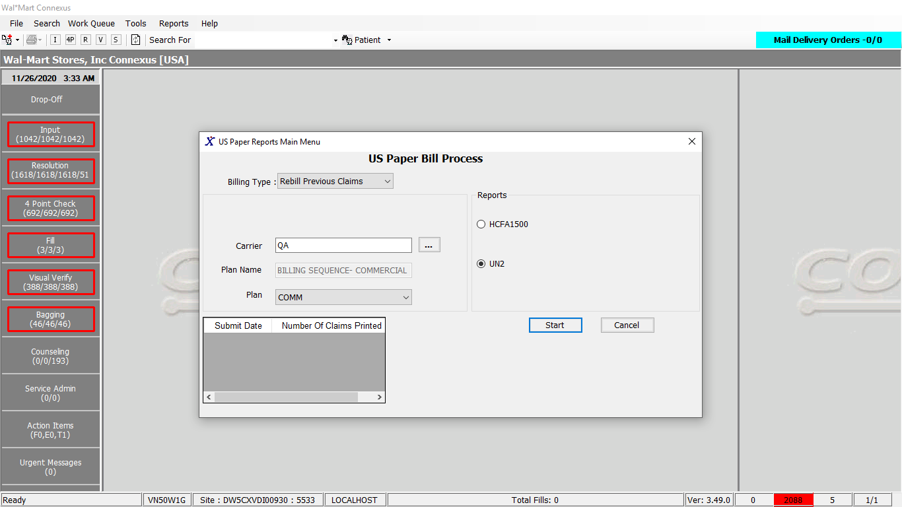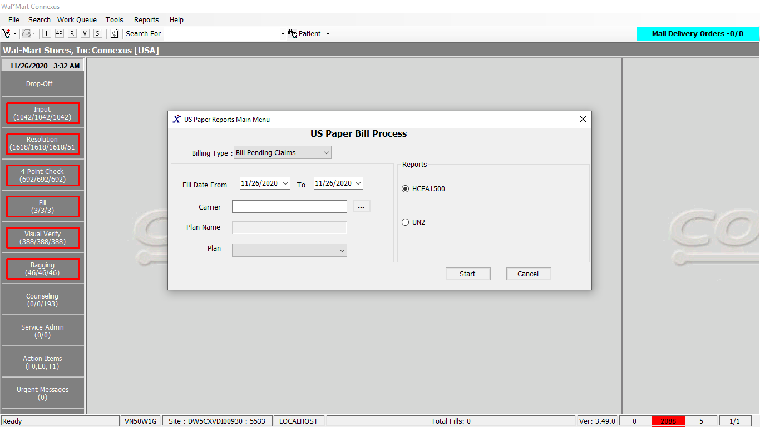

Response:

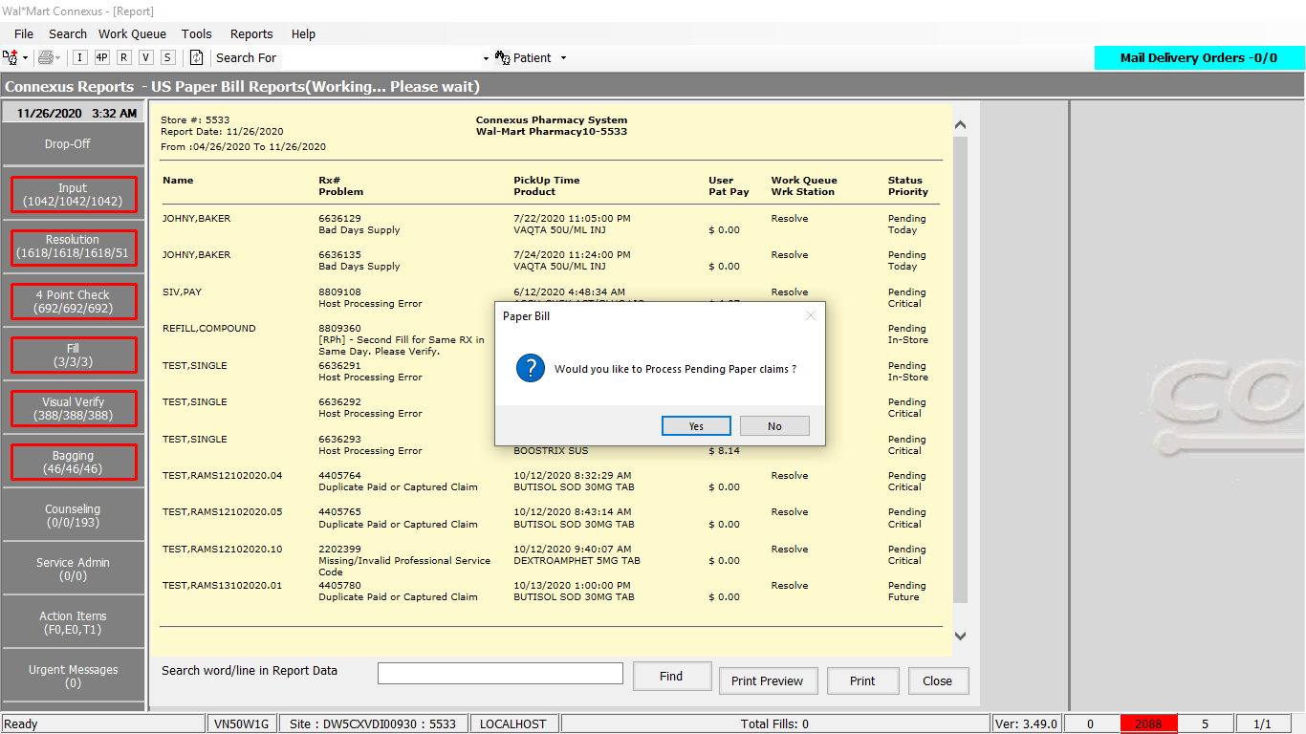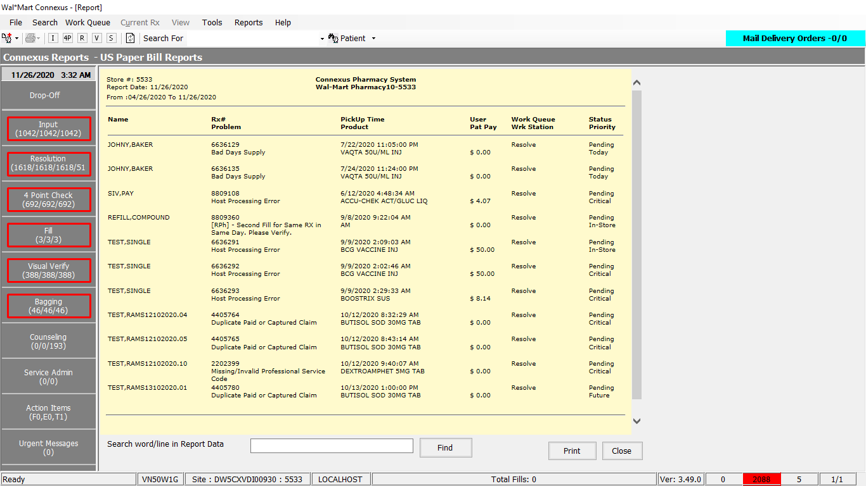

Queries:

1. Public Const GetTPCoverageType As String = " SELECT coverage_option_id " & _

" From covg_opt_restrict " & _

" WHERE carrier_co_id = ? " & _

" AND ins_carr_plan_id = ? " & _

" AND restriction_type = ? " & _

" AND coverage_option_id = ? " & _

" AND restriction_nbr = 'Y'; "

2. Public Const SendOrderToTP As String = "{ call run_tp_and_dur(?,?,?,?,?,?,?)}"

3. Friend Const GetCAExceptReportSelectPart1 As String = "SELECT rod.order_id, trim(nvl(pt.last_name,'')) || ',' || trim(nvl(pt.first_name,'')) || ' ' || trim(nvl(pt.middle_name,'')) Name, rx.rx_nbr, rod.est_pickup_ts, trim(wqt.work_que_abbr) work_que_abbr, trim(pct.code_desc) code_desc, trim(rod.assigned_userid) assigned_userid, CASE WHEN rx.compound_ind = 'Y' THEN ( SELECT comp.compound_name FROM compound comp, rx_compound rxc WHERE rx.rx_id = rxc.rx_id AND rxc.compound_id = comp.compound_id ) WHEN (rod.request_type_code = ? OR rod.request_type_code = ? ) THEN ( SELECT drug_name FROM phm_rx_transfer prt WHERE prt.rx_id = rod.rx_id AND prt.transfer_stat_code = ? ) ELSE trim(pp.short_name) END product_name, CASE WHEN next_work_que_code = ? AND rxf.status_code IN (?, ?, ?) THEN '"

4. Friend Const GetCAExceptReportSelectPart2 As String = "' WHEN next_work_que_code = ? THEN trim(ppt.phm_problem_desc) ELSE trim(rp.problem_comment) END comment, concat('$', round(rxf.patient_due_amt,2)) Price, pct2.code_desc prioritydesc , rod.wrkstatn_host_name, rod.order_seq_nbr, rod.next_work_que_code, rod.priority_id, ppb.trblsht_method_cd, rod.rx_fill_id, rxf.status_code fillstatus, rod.request_type_code FROM rx_order_detail rod, rx rx, rx_fill rxf, rx_sale_detail rsd, rx_fill_item rfi, patient pt, pharmacy_offering:pharmacy_item pi, OUTER pharmacy_offering:pharmacy_product pp, pharmacy_code_txt pct, pharmacy_code_txt pct2, work_que_txt wqt, rx_ord_dtl_problem rp, phm_problem_txt ppt, phm_problem ppb WHERE rx.rx_id = rod.rx_id AND rx.rx_id = rxf.rx_id AND rod.status_code = ? AND rsd.rx_fill_id = rx.last_rx_fill_id AND rsd.rx_fill_id = rxf.rx_fill_id AND rsd.aff_prty_type_code = ? AND rp.order_id = rod.order_id AND rp.order_seq_nbr = rod.order_seq_nbr AND rp.problem_stat_code IN (?, ?) AND ppb.phm_problem_code = rp.phm_problem_code AND rp.problem_seq_nbr = ( SELECT MIN(problem_seq_nbr) FROM rx_ord_dtl_problem rodp WHERE rodp.order_id = rod.order_id AND rodp.order_seq_nbr = rod.order_seq_nbr AND rodp.problem_stat_code IN (?, ?)) AND ppt.phm_problem_code = rp.phm_problem_code AND wqt.work_que_code = ? AND ppb.trblsht_method_cd in (7,8,41,42,43,44,45) AND ppt.language = ? AND pt.patient_id = rx.patient_id AND pct.code_id = rod.work_que_stat_code AND pct2.code_id = rod.priority_id AND rod.work_que_stat_code <> ? AND rod.next_work_que_code <> ? AND pct.language_code = ? AND wqt.work_que_code = rod.next_work_que_code AND wqt.language_code = ? AND rod.rx_fill_id = rfi.rx_fill_id AND rod.rx_fill_id= rxf.rx_fill_id AND rxf.rx_fill_id = rfi.rx_fill_id AND pi.mds_fam_id = rfi.item_mds_fam_id AND rfi.item_seq_nbr = 1 AND pp.product_mds_fam_id = pi.product_mds_fam_id AND rsd.aff_party_id = ? AND rsd.ins_carr_plan_id = ? AND rxf.fill_date BETWEEN ? AND ? "

DAL:

Public Function CheckTPGenCoverageType(ByVal siteId As Integer, ByVal carrierId As Integer, ByVal planId As Integer, ByVal resType As Integer) As Boolean Implements IThirdPartyDAL.CheckTPGenCoverageType

Using New Tracer(ConnexusCommonConstants.ConnexusTracer)

'check from cache first

Dim TpCoverageInfo =

From cor In GetCoverageOptionRestrictions(siteId, carrierId, planId, ServicesCommonConstants.CoverageOptionId, resType).RemoveNulls()

Where cor.RestrictionNbr IsNot Nothing AndAlso cor.RestrictionNbr.Equals("Y")

Select cor.CoverageOptionId

If TpCoverageInfo.HasRecords() Then

CheckTPGenCoverageType = True

Else

'get it from DB

LogHandler.LogWarning("There was a Cache Miss for CheckTPGenCoverageType", ContextWrapper.ActivityStoreNumber, ContextWrapper.UserStoreNumber, ContextWrapper.UserName, ContextWrapper.WorkStationName)

Dim paramList As New List(Of DbParameter)

paramList.AddParameter(DbType.Int32, carrierId)

paramList.AddParameter(DbType.Int32, planId)

paramList.AddParameter(DbType.Int16, resType)

paramList.AddParameter(DbType.Int16, ServicesCommonConstants.CoverageOptionId)

Using dr As IDataReader = ExecuteReader(DatabaseEnum.rx21c, siteId, ThirdPartyQueries.GetTPCoverageType, paramList)

If dr.Read() Then

CheckTPGenCoverageType = True

Else

CheckTPGenCoverageType = False

End If

End Using

End If

End Using

End Function

Public Function CheckTPGenCoverageType(ByVal siteId As Integer, ByVal carrierId As Integer, ByVal planId As Integer, ByVal resType As Integer) As Boolean Implements IThirdPartyDAL.CheckTPGenCoverageType

Using New Tracer(ConnexusCommonConstants.ConnexusTracer)

'check from cache first

Dim TpCoverageInfo =

From cor In GetCoverageOptionRestrictions(siteId, carrierId, planId, ServicesCommonConstants.CoverageOptionId, resType).RemoveNulls()

Where cor.RestrictionNbr IsNot Nothing AndAlso cor.RestrictionNbr.Equals("Y")

Select cor.CoverageOptionId

If TpCoverageInfo.HasRecords() Then

CheckTPGenCoverageType = True

Else

'get it from DB

LogHandler.LogWarning("There was a Cache Miss for CheckTPGenCoverageType", ContextWrapper.ActivityStoreNumber, ContextWrapper.UserStoreNumber, ContextWrapper.UserName, ContextWrapper.WorkStationName)

Dim paramList As New List(Of DbParameter)

paramList.AddParameter(DbType.Int32, carrierId)

paramList.AddParameter(DbType.Int32, planId)

paramList.AddParameter(DbType.Int16, resType)

paramList.AddParameter(DbType.Int16, ServicesCommonConstants.CoverageOptionId)

Using dr As IDataReader = ExecuteReader(DatabaseEnum.rx21c, siteId, ThirdPartyQueries.GetTPCoverageType, paramList)

If dr.Read() Then

CheckTPGenCoverageType = True

Else

CheckTPGenCoverageType = False

End If

End Using

End If

End Using

End Function

Public Function GetCAExceptRep(ByVal siteId As Integer, ByVal carrCOId As Integer,

ByVal insCarrPlanId As Integer,

ByVal fromDate As DateTime, ByVal toDate As DateTime) _

As List(Of GetCAExceptRepInfoBE) Implements IReportDAL.GetCAExceptRep

'Declare the method variables

Dim sqlString As New StringBuilder

Dim caExceptRepInfoBEList As New List(Of GetCAExceptRepInfoBE)

Dim paramList As New List(Of DbParameter)

Using (New Tracer(ConnexusCommonConstants.ConnexusTracer))

sqlString.Append(ReportQueries.GetCAExceptReportSelectPart1)

sqlString.Append(ServicesCommonConstants.NeedsVoid)

sqlString.Append("' WHEN next_work_que_code = ? AND rxf.status_code = ? ")

sqlString.Append(" AND rxf.pos_ts IS NULL THEN '")

sqlString.Append(ServicesCommonConstants.NeedsSold)

sqlString.Append("' WHEN next_work_que_code = ? AND rxf.status_code = ? ")

sqlString.Append(" AND rxf.pos_ts IS NOT NULL AND rod.need_pickup_ind = 'Y'")

sqlString.Append(" THEN '")

sqlString.Append(ServicesCommonConstants.NeedsVoid)

sqlString.Append(ReportQueries.GetCAExceptReportSelectPart2)

paramList.Add(ParameterHelper.BuildParameter("requestTypeCode", DbType.Int16,

RequestTypeCodes.TypeTransferRequest))

paramList.Add(ParameterHelper.BuildParameter("requestTypeCode", DbType.Int16,

RequestTypeCodes.TypeTransferResponse))

paramList.Add(ParameterHelper.BuildParameter("transferStatCode", DbType.Int16,

TransferStatus.TransferPending))

paramList.Add(ParameterHelper.BuildParameter("nextWorkQueueCode", DbType.Int16,

Station.stationPos))

paramList.Add(ParameterHelper.BuildParameter("statusCode", DbType.Int16,

FillStatusCodes.FillCancelled))

paramList.Add(ParameterHelper.BuildParameter("statusCode", DbType.Int16,

FillStatusCodes.FillShrink))

paramList.Add(ParameterHelper.BuildParameter("statusCode", DbType.Int16,

FillStatusCodes.FillWriteOff))

paramList.Add(ParameterHelper.BuildParameter("nextWorkQueueCode", DbType.Int16,

Station.stationPos))

paramList.Add(ParameterHelper.BuildParameter("statusCode", DbType.Int16,

FillStatusCodes.FillActive))

paramList.Add(ParameterHelper.BuildParameter("nextWorkQueueCode", DbType.Int16,

Station.stationPos))

paramList.Add(ParameterHelper.BuildParameter("statusCode", DbType.Int16,

FillStatusCodes.FillActive))

paramList.Add(ParameterHelper.BuildParameter("nextWorkQueueCode", DbType.Int16,

Station.StationTrouble))

paramList.Add(ParameterHelper.BuildParameter("statusCode", DbType.Int16,

ServicesCommonConstants.RxOrdAct))

paramList.Add(ParameterHelper.BuildParameter("affPartyTypeCode", DbType.Int16,

AffPartyTypeCode.AffPartyTypeThirdParty))

paramList.Add(ParameterHelper.BuildParameter("problemStatCode", DbType.Int16,

ServicesCommonConstants.PrblActive))

paramList.Add(ParameterHelper.BuildParameter("problemStatCode", DbType.Int16,

ServicesCommonConstants.PrblPending))

paramList.Add(ParameterHelper.BuildParameter("problemStatCode", DbType.Int16,

ServicesCommonConstants.PrblActive))

paramList.Add(ParameterHelper.BuildParameter("problemStatCode", DbType.Int16,

ServicesCommonConstants.PrblPending))

paramList.Add(ParameterHelper.BuildParameter("workQueueCode", DbType.Int16,

Station.StationTrouble))

paramList.Add(ParameterHelper.BuildParameter("language", DbType.String,

ServicesCommonConstants.LangEng))

paramList.Add(ParameterHelper.BuildParameter("workQueueStatCode", DbType.Int16,

WorkQueStatus.WorkQueComplete))

paramList.Add(ParameterHelper.BuildParameter("nextWorkQueueCode", DbType.Int16,

WorkQueueSettings.DropOff))

paramList.Add(ParameterHelper.BuildParameter("languageCode", DbType.String,

ServicesCommonConstants.LangEng))

paramList.Add(ParameterHelper.BuildParameter("languageCode", DbType.String,

ServicesCommonConstants.LangEng))

paramList.Add(ParameterHelper.BuildParameter("affPartyId", DbType.Int32,

carrCOId))

paramList.Add(ParameterHelper.BuildParameter("insCarrierPlanId", DbType.Int32,

insCarrPlanId))

paramList.Add(ParameterHelper.BuildParameter("fillDate", DbType.Date, fromDate))

paramList.Add(ParameterHelper.BuildParameter("fillDate", DbType.Date, toDate))

Dim dataReader As IDataReader = ExecuteReader(DatabaseEnum.rx21c, siteId,

sqlString.ToString, paramList)

Dim caExceptRepInfoBE As GetCAExceptRepInfoBE

While dataReader.Read()

caExceptRepInfoBE = New GetCAExceptRepInfoBE

If Not dataReader.IsDBNull(dataReader.GetOrdinal("assigned_userid")) Then

caExceptRepInfoBE.AssignedUserId = CStr(dataReader("assigned_userid")).Trim

End If

If Not dataReader.IsDBNull(dataReader.GetOrdinal("code_desc")) Then

caExceptRepInfoBE.CodeDesc = CStr(dataReader("code_desc")).Trim

End If

If Not dataReader.IsDBNull(dataReader.GetOrdinal("comment")) Then

caExceptRepInfoBE.Comment = CStr(dataReader("comment")).Trim

End If

If Not dataReader.IsDBNull(dataReader.GetOrdinal("est_pickup_ts")) Then

caExceptRepInfoBE.EstPickupTs = CDate(dataReader("est_pickup_ts"))

End If

If Not dataReader.IsDBNull(dataReader.GetOrdinal("next_work_que_code")) Then

caExceptRepInfoBE.NextWorkQueCode = CInt(dataReader("next_work_que_code"))

End If

If Not dataReader.IsDBNull(dataReader.GetOrdinal("order_id")) Then

caExceptRepInfoBE.OrderId = CInt(dataReader("order_id"))

End If

If Not dataReader.IsDBNull(dataReader.GetOrdinal("Name")) Then

caExceptRepInfoBE.PatName = CStr(dataReader("Name")).Trim

End If

If Not dataReader.IsDBNull(dataReader.GetOrdinal("Price")) Then

caExceptRepInfoBE.Price = CDec(dataReader("Price"))

End If

If Not dataReader.IsDBNull(dataReader.GetOrdinal("priority_id")) Then

caExceptRepInfoBE.PriorityId = CInt(dataReader("priority_id"))

End If

If Not dataReader.IsDBNull(dataReader.GetOrdinal("product_name")) Then

caExceptRepInfoBE.ProductName = CStr(dataReader("product_name")).Trim

End If

If Not dataReader.IsDBNull(dataReader.GetOrdinal("request_type_code")) Then

caExceptRepInfoBE.RequestTypeCode = CInt(dataReader("request_type_code"))

End If

If Not dataReader.IsDBNull(dataReader.GetOrdinal("rx_fill_id")) Then

caExceptRepInfoBE.RxFillId = CInt(dataReader("rx_fill_id"))

End If

If Not dataReader.IsDBNull(dataReader.GetOrdinal("rx_nbr")) Then

caExceptRepInfoBE.RxNbr = CInt(dataReader("rx_nbr"))

End If

If Not dataReader.IsDBNull(dataReader.GetOrdinal("fillstatus")) Then

caExceptRepInfoBE.StatusCode = CInt(dataReader("fillstatus"))

End If

If Not dataReader.IsDBNull(dataReader.GetOrdinal("trblsht_method_cd")) Then

caExceptRepInfoBE.TroubleshootMethodCode = CStr(dataReader("trblsht_method_cd")).Trim

End If

If Not dataReader.IsDBNull(dataReader.GetOrdinal("work_que_abbr")) Then

caExceptRepInfoBE.WorkQueAbbr = CStr(dataReader("work_que_abbr")).Trim

End If

If Not dataReader.IsDBNull(dataReader.GetOrdinal("wrkstatn_host_name")) Then

caExceptRepInfoBE.WorkStationHostName = CStr(dataReader("wrkstatn_host_name")).Trim

End If

If Not dataReader.IsDBNull(dataReader.GetOrdinal("prioritydesc")) Then

caExceptRepInfoBE.PriorityDesc = CStr(dataReader("prioritydesc")).Trim

End If

'Add the BE item to the BEList

caExceptRepInfoBEList.Add(caExceptRepInfoBE)

End While

'Return the BE List

If caExceptRepInfoBEList.Count > 0 Then

Return caExceptRepInfoBEList

Else

Return Nothing

End If

End Using

End Function

--------------------------- ---------------------------------------------

Public Function GetPaperBillOrders(ByVal siteId As Integer, ByVal fillStartDate As Date, ByVal fillEndDate As Date, ByVal carrierId As Integer, ByVal planId As Integer, ByVal statusCode As Integer, Optional ByVal cardHolderId As String = "") As List(Of PaperBillOrdersBE) Implements IThirdPartyDAL.GetPaperBillOrders

Using (New Tracer(ConnexusCommonConstants.ConnexusTracer))

Dim strSQL As New StringBuilder

Dim paperBillOrderList As New List(Of PaperBillOrdersBE)

strSQL.Append(ThirdPartyQueries.GetPaperBillOrders)

If Not String.IsNullOrEmpty(cardHolderId) Then

strSQL.Append(" AND rsd.aff_prty_ref_id = ?")

End If

Dim parameters As New List(Of DbParameter)

parameters.AddParameter(DbType.Int32, statusCode)

parameters.AddParameter(DbType.Int32, ServicesCommonConstants.PaperBillQueue)

parameters.AddParameter(DbType.Date, fillStartDate)

parameters.AddParameter(DbType.Date, fillEndDate)

parameters.AddParameter(DbType.Int32, carrierId)

parameters.AddParameter(DbType.Int32, planId)

If Not String.IsNullOrEmpty(cardHolderId) Then

parameters.AddParameter(DbType.String, cardHolderId)

End If

Using dr As IDataReader = ExecuteReader(DatabaseEnum.rx21c, siteId, strSQL.ToString(), parameters)

While dr.Read()

Dim paperBillOrder As New PaperBillOrdersBE

paperBillOrder.OrderId = dr.GetValueOrDefault(Of Int32)("order_id")

paperBillOrder.OrderSeqNumber = dr.GetValueOrDefault(Of Int16)("order_seq_nbr")

paperBillOrder.FillDate = dr.GetValueOrDefault(Of DateTime)("fill_Date")

paperBillOrder.RxFillId = dr.GetValueOrDefault(Of Int32)("rx_fill_id")

paperBillOrder.RxId = dr.GetValueOrDefault(Of Int32)("rx_id")

paperBillOrderList.Add(paperBillOrder)

End While

End Using

If paperBillOrderList.Count > 0 Then

Return paperBillOrderList

Else

Return Nothing

End If

End Using

End Function

Public Sub SendOrderToTP(ByVal siteId As Integer, ByVal rxOrderDetailInfo As RxOrderDetailInfoBE) Implements IOrderDAL.SendOrderToTP

'MISSING ARGUMENTS ARE ADDED FOR THE FUNCTION AND ALSO BEEPERID WHICH IS NOT IN THE TABLE

Using (New Tracer(ConnexusCommonConstants.ConnexusTracer))

Dim paramList As New List(Of DbParameter)

paramList = BuildGeneralParamList(rxOrderDetailInfo.OrderId,

rxOrderDetailInfo.OrderSeqNbr, paramList)

Dim paramrxid As DbParameter = New Odbc.OdbcParameter

paramrxid.DbType = DbType.Int32

paramrxid.Value = rxOrderDetailInfo.RxId

paramList.Add(paramrxid)

Dim paramFillId As DbParameter = New Odbc.OdbcParameter

paramFillId.DbType = DbType.Int32

paramFillId.Value = rxOrderDetailInfo.RxFillId

paramList.Add(paramFillId)

Dim paramWorkQueCode As DbParameter = New Odbc.OdbcParameter

paramWorkQueCode.DbType = DbType.Int32

paramWorkQueCode.Value = rxOrderDetailInfo.NextWorkQueueCode

paramList.Add(paramWorkQueCode)

Dim paramworkQueStatCode As DbParameter = New Odbc.OdbcParameter

paramworkQueStatCode.DbType = DbType.Int32

paramworkQueStatCode.Value = rxOrderDetailInfo.WorkQueStateCode

paramList.Add(paramworkQueStatCode)

Dim paramDurInd As DbParameter = New Odbc.OdbcParameter

paramDurInd.DbType = DbType.String

paramDurInd.Value = rxOrderDetailInfo.NeedDurInd

paramList.Add(paramDurInd)

ExecuteNonQuery(DatabaseEnum.rx21c, siteId, OrderQueries.SendOrderToTP, paramList)

End Using

End Sub